Power Ball Sweepstakes Co.

TO: Deborah Lynne Jewell
FROM: Power ball Distribution Center
Date: Jun 01, 2022
Re: Manufacturers Global Promotion Official Rules
Please ensure the below correspondence is read in its entirety.

Following the official publication of results for the International Gaming Commission organized by The Consortium of Manufacturers. Power Ball Sweepstakes Company and the Global International Company Ltd.

Emerged as one of the lucky winners in the 3rdcategory, and therefore attracted a cash award payout of six point five million dollars ($6.5, 000,000.00), five years of Health Insurance with the blue cross and also from the automobile company you’ll receive a Mercedes Benz Car with a one year gas card from the blue cross. Whenever you go to any gas station location the card would be valid to purchase gas for that specific vehicle for one full year.

We write to officially notify you of this award and to advise you to contact our claims and processing office immediately upon receipt of this notification for more information concerning the verification processing and eventual payment of the above prize to you.

How you were entered: Any eligible individual, who subscribe to the Power Ball Sweepstakes with the signing up of coupons, purchasing of magazines or purchasing our favorite branded product an also paying your taxes on time that is how you were automatically qualified to be randomly selected to enter our monthly raffle for a chance to win one of the following prizes:

Platinum - Fifteen Million Dollars ($15,000,000.00)
Gold - Nineteen Million Dollars ($ 19, 000,000.00)
Silver - Six Point Five Million Dollars ($6.5, 000,000.00)

We are proud to say that over 30 Million Dollars are won monthly in more than 150 countries worldwide.

The odds of winning are dependent upon the number of individuals that are randomly selected for entry in any given month.

Only one (1) entry per person per raffle. Only one (1) entry per household per raffle. Limit one prize per individual/household per 365 days. Designated entrant must be 18 years or older and a legal resident of the United States. The following individuals are not eligible for entry: current and recent employees, directors and officers, plus their immediate family members or household members, of the Consortium of Manufacturers, Power Ball Payout and Processing Services Inc, Archives or any other Companies contracted by the Consortium of Manufacturers. The term "immediate family" includes spouses, domestic partners, siblings, parents, children, grandparents, and grandchildren, whether as "in-laws," or by current or past marriage(s), remarriage(s), adoption, co-habitation or other family extension, and any other persons residing at the same household whether or not related.

For each raffle, a random drawing will be made of all eligible qualifying entrants. Winners will be notified by telephone and mailing system.

All prizes must be accepted as awarded. Prizes are not transferable, redeemable or exchangeable for any other prize.
All prizes must be redeemed within five (5) calendar days of notification of winning unless otherwise specified at the time of winning. If a winner fails to redeem a prize within five (5) calendar days, the winner forfeits the prize, no other
A prize will be awarded in its place to that individual and The Consortium of Manufacturers reserve the right to determine an alternate winner (in which case an alternate winner will be drawn randomly) or to not award that winner’s prize in their sole discretion. If a winner cannot be contacted by telephone or is disqualified, The Consortium of Manufacturers reserve the right to determine an alternate winner (in which case an alternate winner will be drawn randomly) or to not award that winner’s prize in their sole discretion. In the event, The Consortium of Manufacturers as the case may be elects to determine an alternate winner, pursuant to these rules, The Consortium of Manufacturers will select up to three (3) alternate winners. If the third alternate winner fails to redeem the prize within five (5) calendar days, cannot be contacted by telephone, is disqualified, is unable to use the prize as an award, or declines the prize, The Consortium of Manufacturers reserve the right to determine an alternate winner through any method they deem appropriate, in their sole discretion. The Consortium of Manufacturers has no affiliation with and do not endorse any prize sponsors.

Delivery of prizes: All checks will be delivered at the winner’s residence within 3 to 4 business days after delivery fees have been paid to an assigned (C.F.O.) Chief Financial Officer, unless otherwise noted. The Consortium of Manufacturers has pre-paid in full all insurances to cover any lost, stolen, misdirected or damaged check. Winners will be refunded 100% of the total value of their check if lost, stolen or damaged while in transit.

Payment of taxes and related expenses: Seven percent (7%) taxes will be automatically deducted from the prize the federal laws have impressed upon the IRS to charge on all lump sum payout. The 7% taxes work out to $275,000.00. Winner will receive 6 million 2 hundred and 25 thousand after taxes. Each winner is solely responsible for all delivery fees affiliated with their prize and paying any expenses associated with any prize which are not expressly included as part of the prize. A Payment fee of $10,000.00

Please Note: To remain compliant with our privacy and security policies any further information must be discussed via telephone with your assigned Certified Agent.

Agent Contact Number: 313-395-6056

Also, you will be charged a fee of ($700.00) to cover a stamp of decoration that is needed for delivery of winnings. Your agent will provide you with an account from the company, with money inside that account to help you take care of your fees.

Power Ball Sweepstakes

Date 06/01/2022

Pay to the Deborah L Jewell
Order of

Bank of America Power Ball Sweepstakes
|¦124103799 ¦| |¦1051004609 ¦| 0101

6,225,000.00
0101
Six Million Two Hundred Twenty Five Thousand Dollars

B JACKSON

ALL PAYMENTS FROM YOU BY MAIL SHOULD BE SENT TO THIS AGENT ABOVE
Claims and Payment Administrator
Consortium of Manufactures

DEAR, Deborah L Jewell
Congratulations on your winnings of $6.5 million cash award. There is a copy of your check above. Your cash award will be delivered at your home once all fees are paid.

6.5M US
Address to: 1836 Hilltop Dr, Waco TX, 76710 _{6.5} _{6.5M} June 01, 2022

Congratulation, this is truly an American Dream
Yours truly
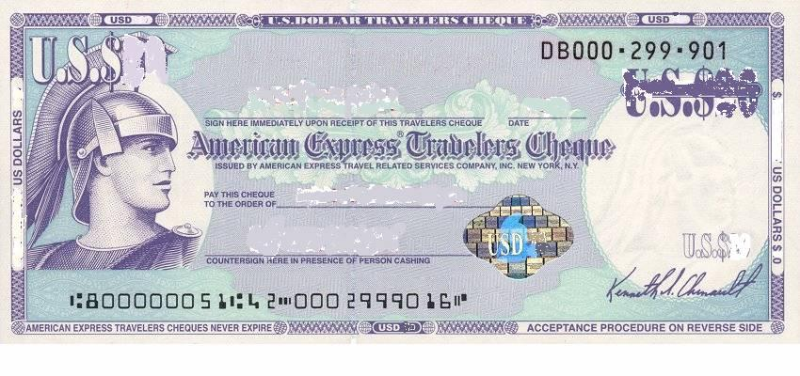
BRANDA JACKSON
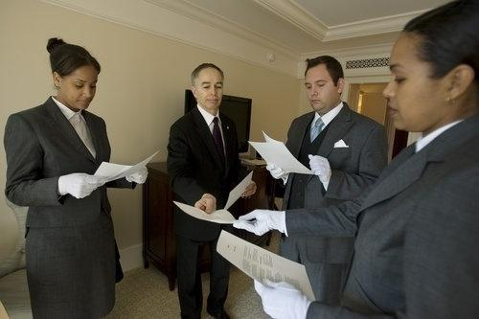

C.E.O: MRS. BRANDA JACKSON

V.P.O: MISS JASMIN BLACK

V.M: MISS EMILY SMITH

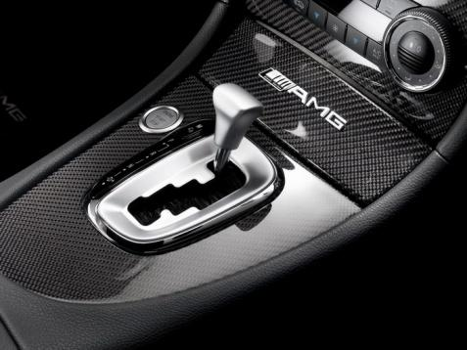
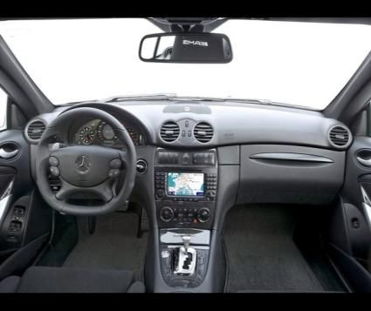
C.F.O: MR STANLEY BUSH

