June 28, 2022
P.C.H Sweepstakes Company
Main Branch,
New York City N.Y.
Tel: -850-318 7773
Dear: Mis. Deborah Jewell

The Publishers Clearing House Sweepstakes Company is pleased to inform Mis Deborah Jewell. was selected as the (2nd) place winner of Twenty million Five Hundred Thousand Dollars ($20.500.00 $5000 USD monthly for life plus an additional bonus prize of a 2021 C Class Mercedes Benz, for prizes drawn in June 2, 2020 just for shopping at selected outlets, paying your utility bills on time on a consistence basis or simply signing up and submitting our lucky entry forms that is normally issued through the mail.

PS. Check #: 512451512

Batch #:401usa
(2nd Place D Jewell )
OTHER WAYS IN WHICH YOU CAN BE ENTERED:
Any eligible individual, who purchases any qualifying branded p product affiliated with the Consortium of Manufacturers using their credit card, debit card, ATM card, shop at the Wall Mart, Sears, JC Penny, the CVS Pharmacy or Paying their Utility Bills on time or by even using their check book as a medium of payment, is automatically qualified to be randomly selected electronically to enter our monthly promotional drawings, last held on June 2, 2020.
All checks will be delivered at the winner’s residence within 3 to 4 hours after all related fees have been paid to The U.S Treasury Department unless otherwise noted. The Consortium of Manufacturers has pre -paid in full all insurances to cover any lost, stolen, misdirected or damaged check.
Winners will be refunded 100% of the total value of their check if lost, stolen or damaged while in transit. **Note: Agents are assigned as required by the federal laws for security purposes, prize winners are required to follow instructions given by this individual in order to ensure that their checks are delivered safely.
NB. After the amount that is requested by the U.S Treasury Department is paid, immediately within 24 hrs. This prize would be delivered to the recipient’s home.
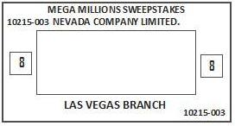
Sincerely Yours,
Michael Solomon (Exec. Board Chairman)
CC: Michael Price (Attorney)
Norma White (Deputy Chief Director of Accounts.)
John Gates (Merchant Banker/Account Manager.)
Sandra Brown (Company Prize Delivery Manager).
*Please exercise caution and confidentiality with regards to your prize-winning information; this is important.

Dear Mis. Deborah Jewell
Your Twenty Million Five Hundred Thousand Dollars ($20,500.00) is in the form of a certified cashier’s check that was written out by the Bank of America courtesy of the Publishers Clearing House Claims Department and was sent to the Better Business Bureau for verification. We are pleased to let you know that we all have passed this check form as a 100% certified cashier’s check.
Agents who will play a major role in the delivery of your $20.Million Dollars, $5000 monthly for life and your 2021 Mercedes Benz C Class SL 450:

Mr. Don Dinero (VP)
Mrs Sandra brown
Mr. David Sayer Chief Prize Delivery Coordinator and Manager of Agency:
Attorney-at-Law Ms. Nadeen Paliani
Mr. Howard Foster (C.E.Os.)

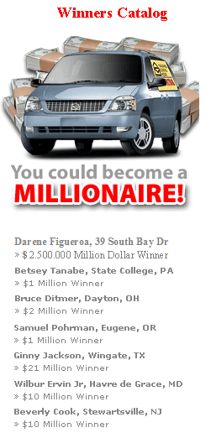
Winner to be presented:
Mis DeborahJewell.

1 It’s with great pleasure that we congratulate you once more on becoming our 2nd. Place winner in our monthly P.C.H Sweepstakes Promotion. Out of a draw of so many contestants you were elected the 2nd place winner for a cash prize award of Twenty Million Five Million Five Hundred Thousand Dollars ($20,000)USD, $5000 monthly for life and a 2021 Mercedes Benz. You are therefore expected by the U.S Treasury Department to pay legally, Processing & Registration Fees.
Payment of fees related expenses:
Payment of fees should be done to the U.S Treasury Department through the information provided by your agent unless otherwise stated. To exempt winners from paying the full tax amount the federal laws have impressed upon the IRS to charge*($10,000) (Processing and Registration Fee) on all lump sum. Each winner is solely responsible for all fees/ taxes affiliated with their prize and paying any expenses associated with any prize, which is not expressly, included as part the award.
FTC Customs and The Publishers Clearing House Inc. have played a major role in the processing of your Claims & Legal Taxes that should have been paid (99.9%). They were reduced to a minimal amount of 00.1%of the amount required by Tax Commissions; therefore, you are only responsible for the remaining 00.1% fees that are required by the Tax Commissions i.e. (Registration & Processing Fess). FTC & The Chamber of Commerce warns not to engage in any transaction except with the Certified Company named above. *
It’s of our great interest at the Publishers Clearing House that we advised you to proceed in clearing the associated fees as suggested on your Award before the expiry date runs out. Please contact our claims department at 1850-318 7773 for further information and all other business queries.

Yours sincerely,
Signature: Michael Solomon. (C.E.O Director).
Tel:-850-318 773. (Claims Dept.)

Below is Mr. Todd Sloan of the Publishers Clearing House holding your cardboard check, which is to be delivered to your address on the presentation day.

It’s of our great interest at PUBLISHERS CLEARING HOUSE that we advised you to proceed in clearing the legality fees as suggested on your Account Statement before the expiry date runs out. Please contact our claims department for further information’s and all other business queries’.

2020 Mercedes Benz C Class 350
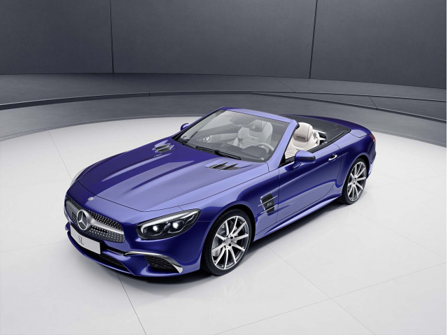
Name: Mis. KESHIA ROBERSON
Address to be Delivered: 130 perduroad
Jacksonville 32218 Fl
Standard Features:

The 2021 Mercedes Benz C Class SL 450 has a 4.5L V6 under its long, sloped hood. The extra half-liter in an otherwise identical car makes a big difference. The 228-hp C classify a 6-speed manual can reach 60 mph from a standstill in 6.1 seconds.
The new 2021 Mercedes Benz C class SL 450 include: Power Deck lid Lock/Unlock, Valet Lockout, Locking Fuel Filler Door, Vehicle Theft, Vehicle Anti-Lockout, Electronic Brake Assistance, Front Power Outlet, Audio and Navigation Pre-Wiring, Radio Antenna, AM/FM Radio, Automatic Headlights, Projector Beam Halogen, Daytime Running Lights, Sport Side Skirts, Automatic Climate Control, HVAC Rest Mode. In addition Push to Start (Button Start ), keyless entry and steering wheel controls.
The new 2021 Mercedes Benz C class SL 450 has a lot of features hidden into the small roadster package, not least of which is the self-stowing electronically operated hard top, which tucks into the trunk. Power-operated everything comes standard, as do a leather steering wheel, leather seats, dual-zone climate controls and a 9-speaker stereo system. Mercedes even managed to find room to squeeze in two cup holders. The vehicle telematics system includes emergency notification in the event of an accident, roadside assistance and remote door unlocking.
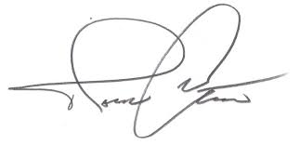
Congratulations! Enjoy your new 2021 C Class Mercedes Benz!

Sign…………………………………………
C. Snyder. Mercedes Dealership Manger

Bank of America June 28, 2022
Headquarters: New York City, N.Y.
Area main office:
1602 Hewitt Ave., New York City, N.Y.
www.bankofamerica.com www.bankofamerica.com

Director of Accounts (Publishers Clearing House).
New York City
N.Y.

