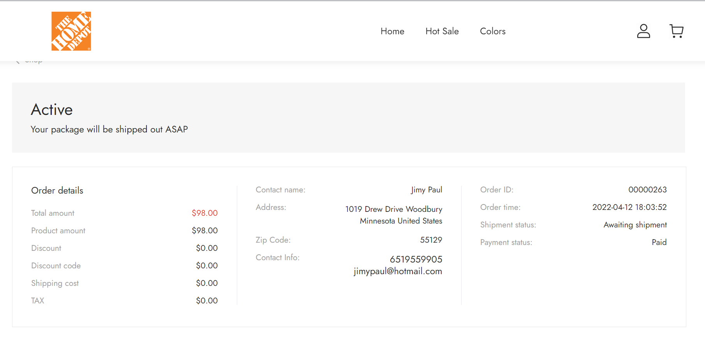

https://www.hphgmedede.shop/order/339747-00000263?spm=..checkout.order_status_1.1

