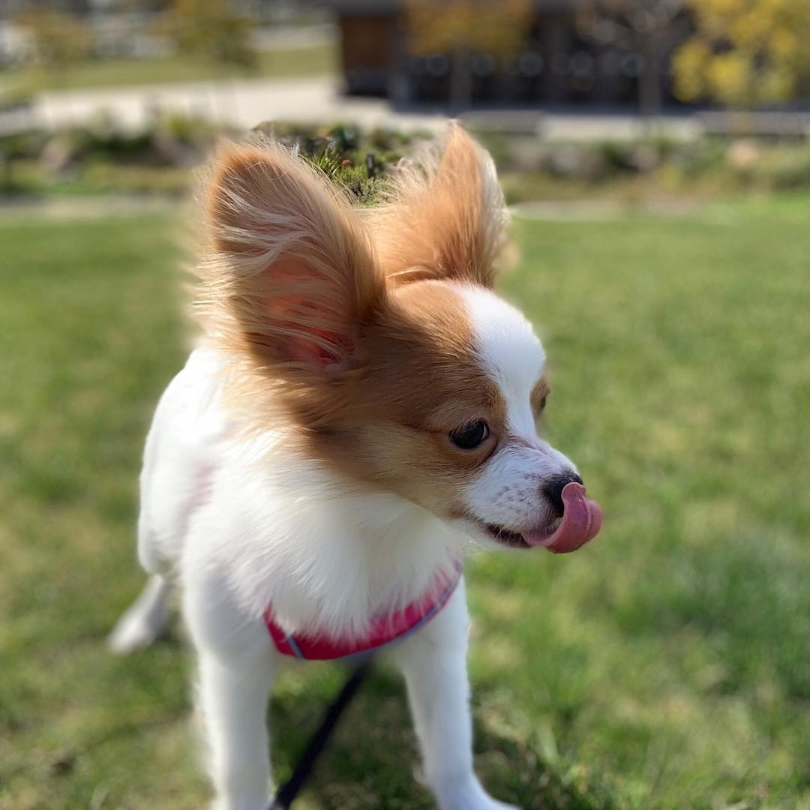

Contact Us
Take a gentle walk through our AVAILABLE PUPPIES page and fill out our CONTACT FORM below to purchase your dream Pet. Our Puppies come with;
NUTRITION**
Health Certificate
Deworming
Shots-to date
Money back Guarantee

Full Name:
Phone Number:
Email Address:
State/City:
Puppy Name:
Select Puppy
- Select Puppy
- Allan
- Popy
- Hans
- Brok
- Lucy
- Jenni
- Moss
Message:
Send Message

Woodland Papillon Puppies
Phone: Request Via Email
Email: idelparish@gmail.com
Hours: Monday To Sunday: 24/7
We do ship your puppy to the closest airport in your location after which the puppy is then delivered to your home address, so you do not need to leave your home to go and pick up the puppy from the airport. This process is professionally handled by the shipping agent who is in charge of shipping and delivering your puppy in perfect health condition. We chose air transport because it is the fastest and it is less stressful for the puppy.
We do issue you the flight schedule of the puppy after we ship him so that you should know the time he arrives in your city. So we advise you to be at home an hour or two after the puppy lands in your city because the delivery van will definitely be bringing the puppy to your home address. Once the puppy is brought to your home address, we expect you to examine the puppy physically to make sure he has not been injured or maltreated in any way. You shall need your government-issued ID card or Drivers' license to identify yourself before signing to collect the puppy. Please make sure to give us a call once you get your puppy and also don't forget to comment on our website. Thanks for your cooperation and we wish you the best with your new family member.
WHO WE ARE

ABOUT US

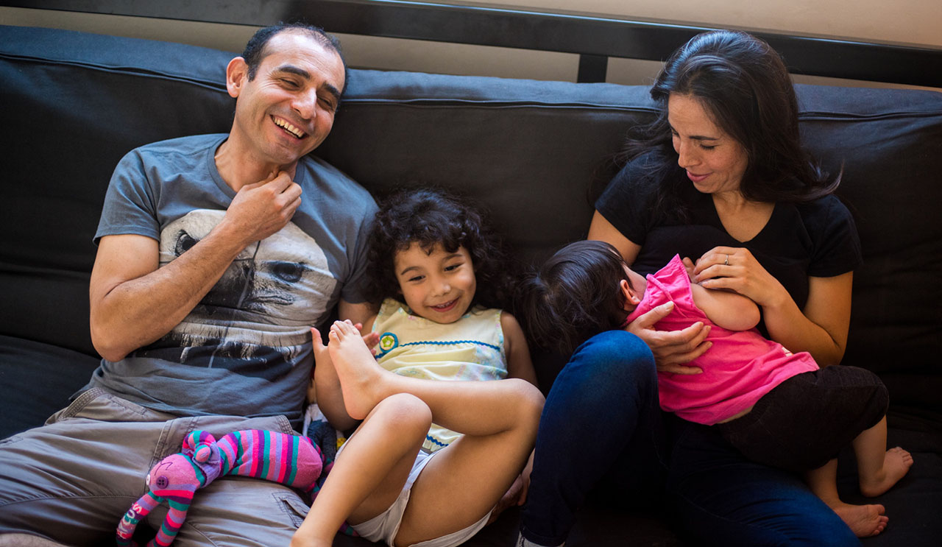
Our goal is making lives of our clients better by placing only healthy papillon puppies into caring homes. We do not keep puppies in cages, aviaries or individual houses. We live in the house and our puppies are full-right members of the family and have constant contact with people, kids and other pets, which is important for the socialization of papillon. We do not have a lot of puppies and we have the opportunity to pay enough attention to each of our puppies! Our papillon are tested for the any diseases almost always: This makes it possible for us to have only healthy papillon. we have a 1 Year Health Guarantee that protects the puppies incase any health issues arise.

NOTE:
To buy a puppy is possible only when it is at least 8 weeks of age and fully vaccinated.
We also ship by cargo or send by courier to the airport closest to you. The photos of our puppies are presented on the site.
We will be happy to advise you and answer all your questions.
We will give recommendations for the care of a puppy.

HERE AT WOODLAND PAPILLON PUPPIES, IT IS OUR MISSION TO HELP YOU GET THE PERFECT COMPANINON PAPILLON PUPPY YOU HAVE ALWAYS WANTED.

ello Jan, I'm texting about my Papillon puppy for sale Jenni. I just emailed you, read and respond.
I haven't received the email yet Jansphr@gmail.com
Yes you can come and pick up the puppy but you will have to make a deposit of $300 before coming. When you get here, you pay rhr balance and get her.
Ok -
Deposit by Zelle. Let me know when you are ready and I will provide details.
How do I give you the deposit? Is it secure? Please don't get offended , but Do you have references so I know you are legit and I will be getting the right dog? I just haven't done this before
You can find reference on our website. We are legit and only want good homes for our puppies. Your deposit is secured and we offer a 30 days money back guarantee for all purchases. The total fee to have the puppy shipped to you is $750. if you decide to have her delivered or to pick up, it all depends on you.
Sounds good - your baby will be my baby for sure.
Thank you
Check your email
You have to send me a screenshot of the payment confirmation.
Hello Jan, I'm texting about my Papillon puppy for sale Jenni. I just emailed you, read and respond. I haven't received the email yet Jansphr@gmail.com Yes you can come and pick up the puppy but you will have to make a deposit of $300 before coming. When you get here, you pay rhr balance and get her. Ok - Deposit by Zelle. Let me know when you are ready and I will provide details. How do I give you the deposit? Is it secure? Please don't get offended , but Do you have references so I know you are legit and I will be getting the right dog? I just haven't done this before You can find reference on our website. We are legit and only want good homes for our puppies. Your deposit is secured and we offer a 30 days money back guarantee for all purchases. The total fee to have the puppy shipped to you is $750. if you decide to have her delivered or to pick up, it all depends on you. Sounds good - your baby will be my baby for sure. Thank you Check your email You have to send me a screenshot of the payment confirmation.
