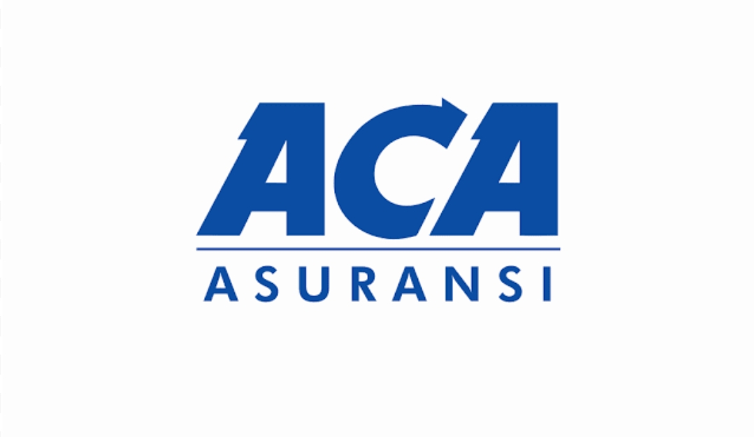
101 Winners Crescent , Jericho NY 11753.
Dear, Joyce Benson
We’re pleased to announce that you have been selected as our Lucky winner for the mega prize promotion held in March 2021 sponsored by the International Sweepstakes Cooperation ™️ .
You have won Five Million Five Thousand Dollars
(5,000.00), and will also be receiving a weekly installation deposit of Five Thousand Dollars ($2000.00) every week for life.
Therefore your prizes will be disbursed to you by our authorized delivery agents of the prize patrol team within 72hrs post your notification of prize.
Your Mercedes Benz will be physically delivered to you at your residential address on file or at desired location of your choice and your cheque (check) prize will be disbursed to you via our affiliated sponsors throughout there finance department.
We have over 15 sponsors here in your City and Province and will authorized your release with the sponsor that you have chosen preferably one that you are already associated with for convenience, professionalism and security.
Moreover your funds won in the Sweepstake will be electronically Wire Transferred or Directly Deposited to you by the Federal Deposit Insurance Cooperation (FDIC) and will be originated from the state of Florida, United States, which will be facilitated through our department.
Henceforth your sponsor(s) chosen by you the recipient to receive your Sweepstakes Prize Win Disbursement will instantaneously dispense your Five Million Dollars (5,000.00) to you after you have paid your taxes and fees with the Internal Revenue Service (IRS), the Federal Deposit Insurance Cooperation (FDIC) and Canada Revenue Agency (CRA).
Taxes and fees are 0.5% of what you won which results to
Five Hundred Dollars
(500.00). After fees are successfully completed you will be issued with your disbursement and release receipt to authenticate and dispense your funds.
Disbursement and Release receipt will have your name, address, release number, date and time of transaction which will be issued to you by the bank teller at the sponsor you have chosen.
We are pleased to be apart of your transition to become a multimillionaire and is looking forward to seeing you receive your Sweepstakes Prize Win Disbursement as soon as possible.
You now have at your disposal Five Million Five Hundred
Thousand Dollars ($5,000.00) and will be receiving Four Thousand Dollars ($2000.000) every week forever.
CONGRATULATIONS!
For further details please email:
Americancashawards330@gmail.com or Contact your informing Agent.
Signature: M.Brown __. Date: 08/11/2021_
