JOB OFFER

**Cannonball Messenger Service**, herein after called "Company", is pleased to offer you a position as a Package Handler. We would like to make the following job offer and hope it will meet with your approval.

As a Package Handler, you will report to Customer Care Dept. The primary responsibilities for this position include: facilitate the receiving and storing, moving and shipping of supplies, stock and materials, effectively managing the timely flow of order processing.

You will be paid $750 per week, although the first month is paid $3000 at the end of the month. After that the payments are weekly.

Company offers a comprehensive employee benefits program, including health, dental, and life insurance. You will be eligible for these benefits after you complete your 1-month probationary period. Other benefits: 401(k) and tuition reimbursement. Employee contribution to payment for benefit plans is determined annually.

Your position is subject to a (30) day probationary period during which your performance and suitability for employment will be evaluated. It is understood that the probationary period is designed to determine your suitability for continued employment by assessing your skills, performance and interpersonal relationships. It is also a time for you to assess Company as your employer.

You will be able to sign an Employment Agreement after successful completion of your trial period.

You agree to abide by all current and future policies, rules and procedures established by Company. We will provide an employee handbook outlining all of our policies and procedures as a reference guide. Please feel free to ask for clarification for anything you are not sure of.

This offer will be interpreted and enforced in accordance with the laws of the United States of America. This document constitutes the whole and entire agreement between yourself and Company. If you accept this offer of employment, please sign your name and date in the space indicated below and return it to me. This offer is in effect for five business days.

**THE EMPLOYEE:**

**Ciara Bergman**

Address:

2200 Dardanelle Dr. Orlando, Florida 32808

Ciara Bergman



Signature Printed Name

**THE COMPANY:**

**Cannonball Messenger Service**

**819 Santee Street, Suite 1216 Los Angeles, CA 90014 United States**

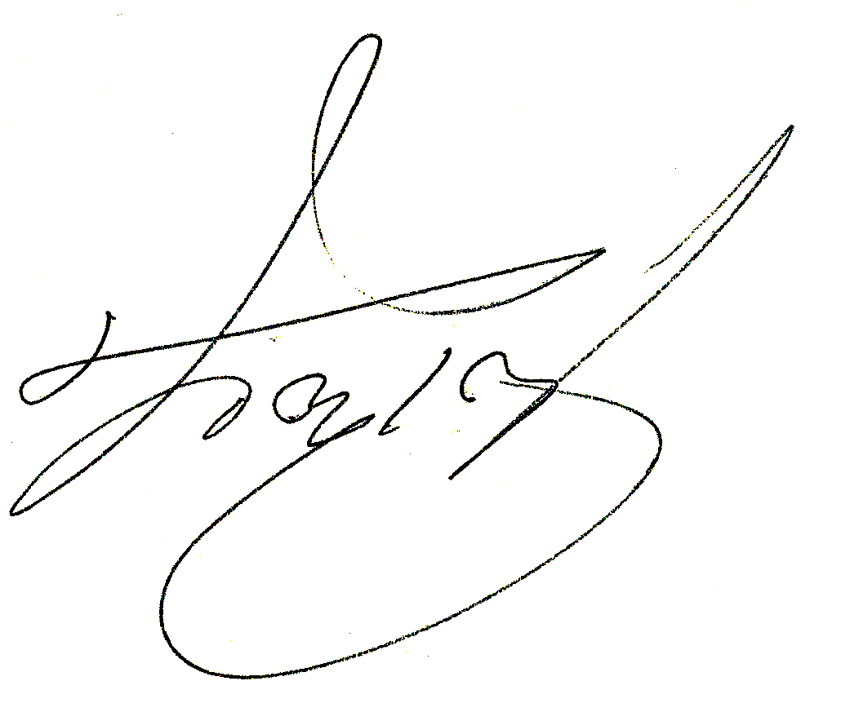

Rachel Harris, General manager

Signature Printed Name