JASON MATTHEWS DELIGHT HOMES

Finding Luxury and Affordable
RENTAL RECEIPT

Address of the Property: 3220 Hatchet Bay Dr, Charleston, SC 29414. UNIT 218
Property Agent: John C. Matthews
Tenant’s Name/Phone No: (My name)

Today’s Date: July 26th 2021

This confirms receipt of $1,800 as rent for the period of 1 month for the premises listed above.

Amount Paid: $1,800

Balance: None

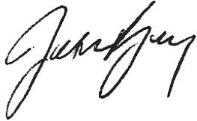
Total Amount:_ $1,800
Property Agent Signature __________

Note: You are going to come with your payment receipt on your move in date to collect your keys.

