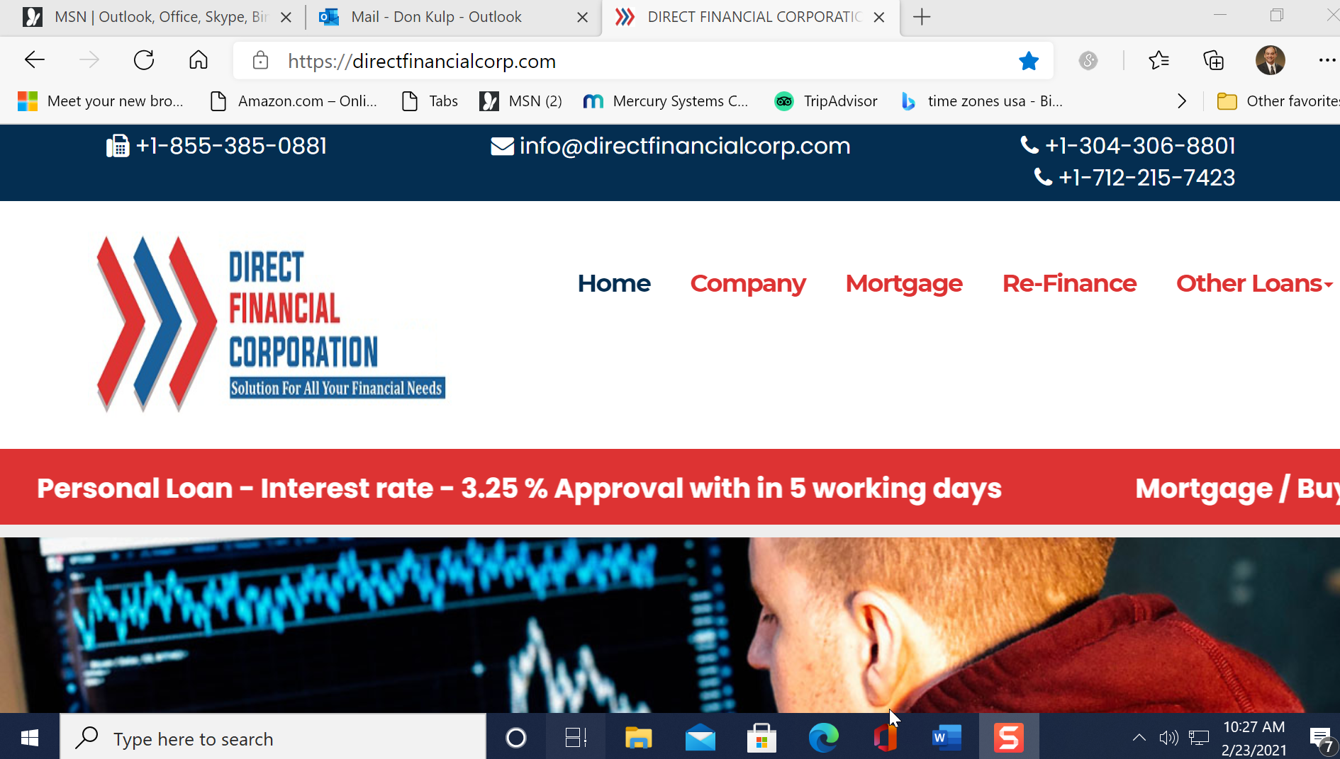
https://directfinancialcorp.com/personal-loan/
DFC Company representatives:
Jerry Wilson (ceo) - CALIFORNA Cell #951-290-5387
Matt Mercer – IOWA Cell# 712-215-7423 Loan Agent
Paul Gomperz – Lawyer Pennsylvania Cell #717-347-0067 Funds sent to : $ 357.00 lawyer fee, $1845.00
3 Superior Drive #627
Natick
Ma. 01760
Frank Macdonald AMOUNT SENT $1,715.00 01/28/21
Bank of America AN#000595567698
Routing Number: 026009593

Personal Loan

DIRECT FINANCIAL CORP is an online and neutral online market place company and a financial broker, consulting firm licensed by the Department of Business Oversight. Established in 2014 with different trading styles and names, we provide guaranteed plate form and superior consulting services to our customer to obtain Personal Loans (Unsecured/ Secured Loans) in all 50 states.

APPLY WITH US IF YOU ARE ANY ONE OF THEM.
- Application declined multiple times while applying for Personal Loans.
- Bad credit score.
- Not finding the right property.
- Do not have a sum of money to pay down payment.
- No idea about the Mortgage and Home loan procedure.

We Offer such loans in this category.
- Credit Card Consolidation Loans
- Debt Consolidation Loans
- Home Improvement Loans
- Vacations Loans
- Study Loans
- Loans for Occasions
- Medical Loans
- Vehicle Loans
- Higher Purchase Loans
- Metal Loans
- Or for any of your personal financial Needs

Lowest APR Guaranteed & Approval in bad credit as well

We reapply with another Lender if declined at first attempt

We are your dedicated advisor and we assure safe closing

Please go through with procedure and documents required for closing your loan. For any query you can always call us on (+1-304-306-8801 / +1-712-215-7423) during working hours and we are more than happy to assist you.

Why DIRECT FINANCIAL CORP for Personal Loans
- We first screen your financial situation and strength.
- We internally audit them and modify the required changes.
- Submit your complete packaged file to our Investor Panel.
- Review of all options available in the market before we advise
- We show you multiple options for repayments and APR to choose the compatible one.
- Fast application processing and quick turnaround on requests.

DOCUMENTS REQUIRED FOR PERSONAL LOANS
- Primary Identification proof
- Bank statement (3 months)
- Income proof (pay stubs / Tax Documents)
- Credit Report (If Available)
- Statements of Outstanding Debts.
- Current Mortgage Statements
Related documents to other properties owned by Applicant (If Any)

To verify your address and age, you will need to be ready to provide:
- Personal Identification
- Address
- Income
- Age

One piece of primary identification
(Any one of them mentioned below.)
- Current driver’s license
- Current U.S. government issued non-driver identification card
- Valid passport
- Current government issued alien identification (i.e. Vis a or Green Card)
- Current armed forces identification card

One pieces of secondary identification.
(Any one of them mentioned below.)
- Current credit or debit card with an embedded photo
- Employment badge/pass with the following:
- Recognized company name
- Applicant’s name
- Applicant’s photograph
- Current bank statement
- W-2 that includes the applicant’s Social Security number
- Birth certificate with a raised or embossed seal
- Current permanent resident card
- Utility bill

To verify your income, you may be required to provide one or more of the following documents.
- Pay stubs
- Signed verification of employment letter from the employer

The letter MUST:
- include the income amount.
- be dated within 30 days of the application date.
- Payroll records or schedule of payments made to employee dated within 30 days of the application date
- W-2s that meet the following requirements:
- The W-2 displays the same employer.
- The loan application date MUST be within 90 days of the due date of the tax return for the year of the W-2.

Pension & Social Security:

Bank statement dated within 30 days of the application date showing direct deposit of one of the following:
- Social Security income
- Pension or retirement income
- Retirement or Social Security award letter
- Copy of the Social Security check dated within 30 days of the application date

Self Employed:
- Past two years’ tax returns

Consumer friendly procedure to process the personal loan applications.
- You could have your money as soon as you send us the documents and we assign an investor!
- Apply Now and Get an Instant Response
- We’ll send Your Application to you via Email/ Fax/Post/personal web based link
- Discuss your options with a qualified loan specialist
- Interest rates are based on various factors, which include your income and Documents. Credit Score does not matter in Personal loan with us.

Benefits of Personal loans.
- Exceptional customer service
- No late Repayment costs
- Low fixed APR starting at 1.5%
- Decisions as fast as 24 hours
- Get your money the next business day
- Make one low, fixed monthly payment
- Fast and easy online process to get funded
- Flexible financial tool to help you meet your goals
- No prepayment penalty, Nominal packaging fees
- No Credit search required.

Exceptional Customer Service and Different from other loan providers.
- Personal loans offered by multiple associated lenders & Guaranteed packaged and Audited by DIRECT FINANCIAL CORP have been initiated to solve numerous financial issues.
- Personal loan rates are claimed to be extremely competitive which 2.5 % onwards.
- Even though you might have been rejected because of a poor credit score earlier, you will surely be consider effective alternatives and receive personal loans.
- With bad credit, bad Income DIRECT FINANCIAL CORP is the only one trusted financial institution and consulting firm which offers ultimate and easy going borrowing options for all kind of customers.
- The average time needed for application processing is a not longer 2 days with us.
- No credit score barriers.
- All and rejected applications from other banks earlier are offered a simplified, high priority treatment & procedure.
- Interest rate is always between 2.5% to 5% variable on each case.

This type of loan is not available with high street national Bankers or Lenders so you can apply by phone or filling up an online form. You can easily check your status with DIRECT FINANCIAL CORP.

Our helpful Personal Loan advisors, always just a call away (+1-304-306-8801 / +1-712-215-7423)

Our Investors
Previous

Next
- 1
- 2
- 3
- 4
- 5

DIRECT FINANCIAL CORP
DIRECT FINANCIAL CORP is the first of such kind. We invented a pattern of providing all financial services including Loans Mortgages, Refinance, Project designing and capital funds, Along with multiple debt solutions and mainly in to providing guidance to Package the loan files.

Quick Links
About Us
Personal Loan
Debt-Solutions
Re-Finance
Mortgage
Contact Us

We Are Here
Do you Care to explain:

132 W Oak St

Arcadia, FL 34266
Building
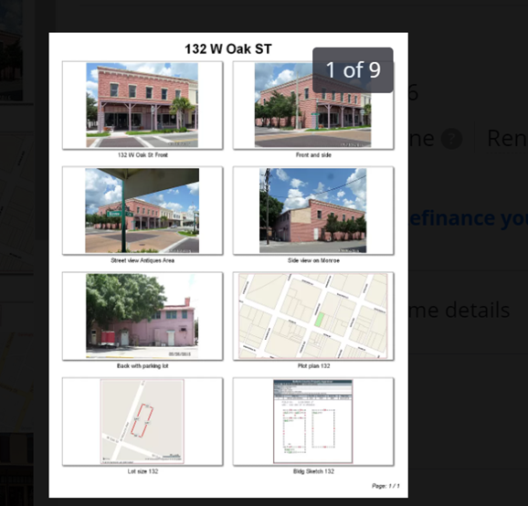

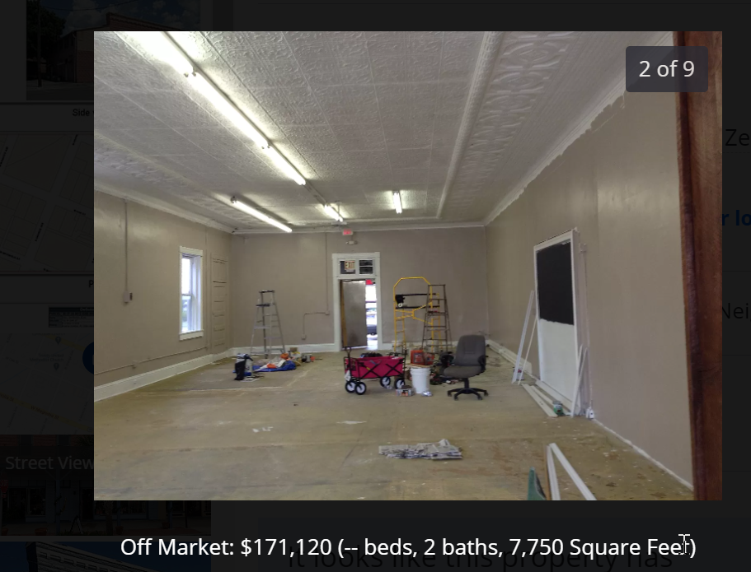

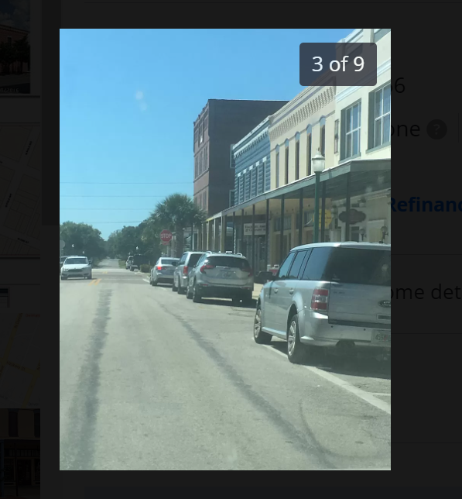

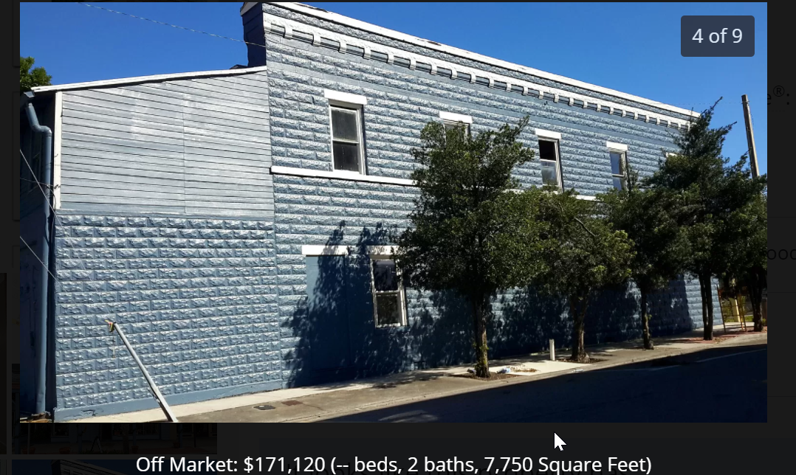

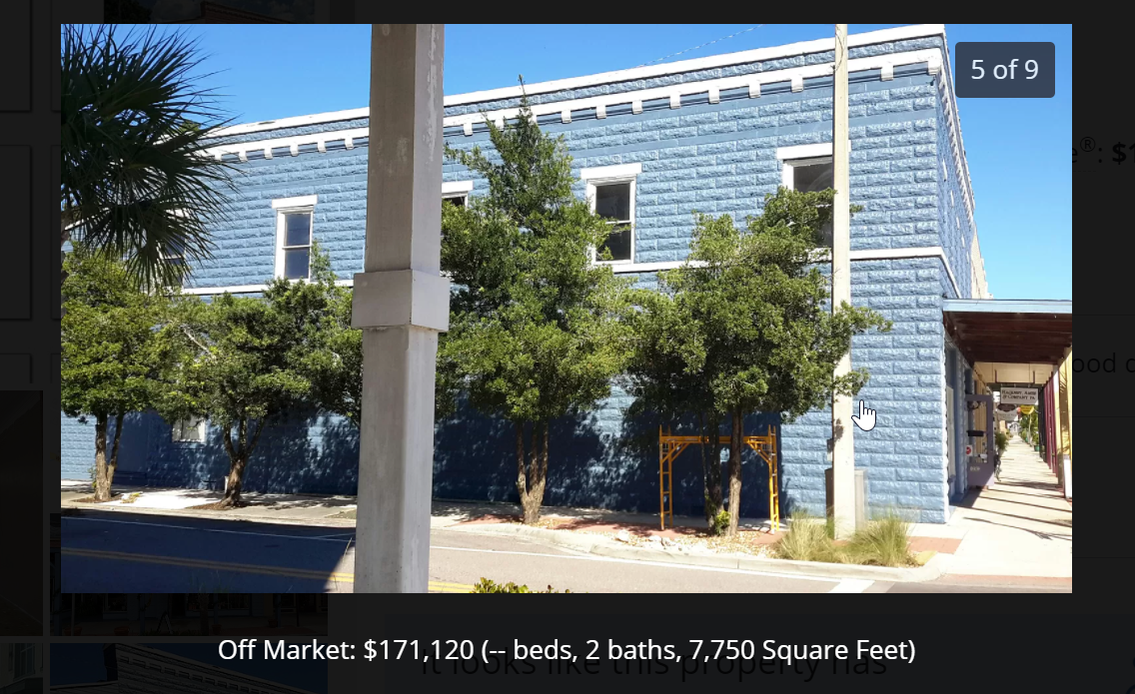

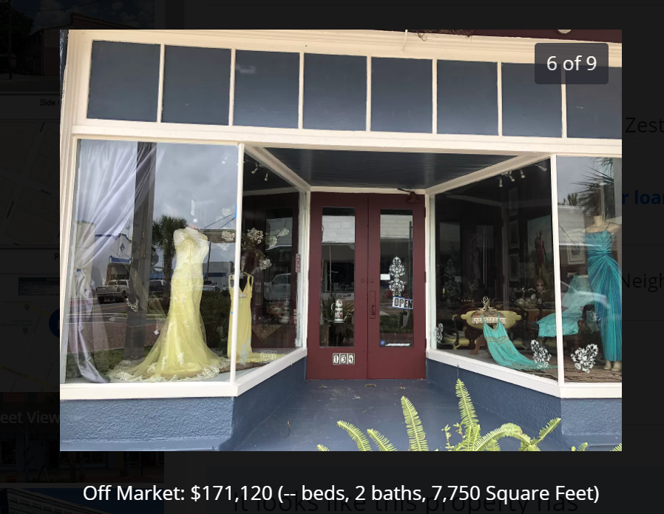

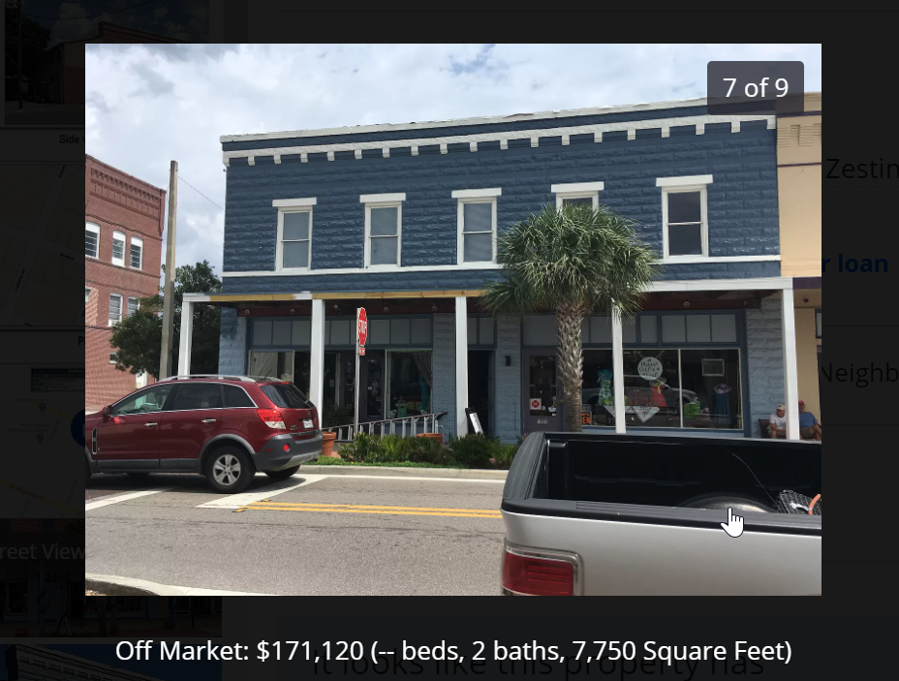

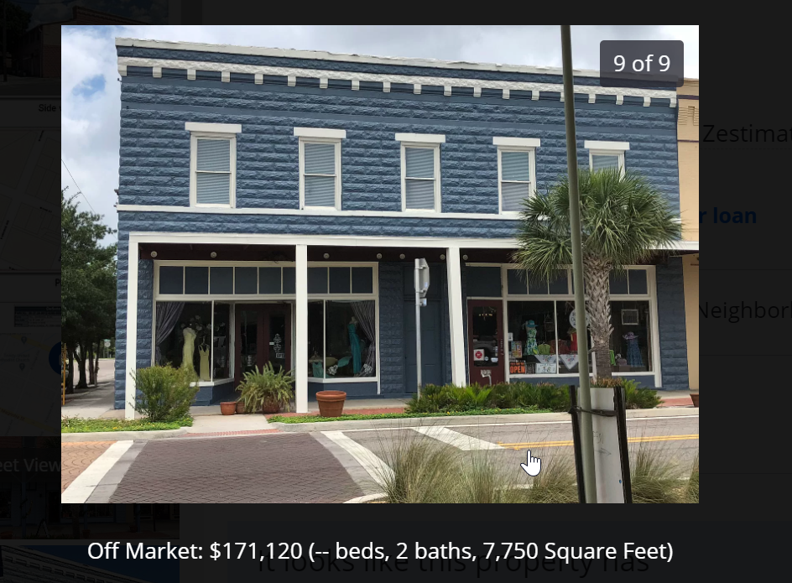

1ST Reported Business Address

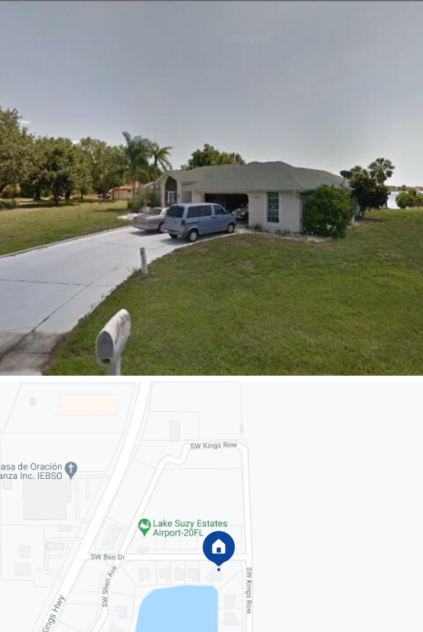
11539 SW BEN DR. Lake Suzy, FL. 32469

Paul Gomperz
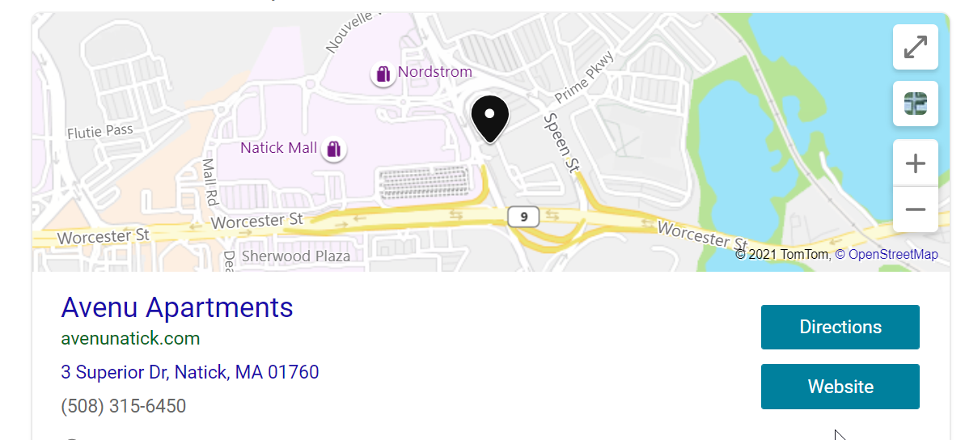

Lorna A• Nov 15, 2020
I am victim of this company represented by Matt Mercer Loan officer and a lawyer Paul Gomperz. I thought they were legit. I paid to them all they asked for but did not receive the loan money at all to refinance my house. Now I’m at a loss. Bank of America informed me that the wire transfer I made to their bank they were not able to receive any funds back. They told me I was scammed by fraud scammers. God will punish the people who takes advantage of other peoples hard worked earned money. Shame on you Matt Mercer and Paul Gomperz and the other people that works for Loan On Step. I am praying that the authorities will find all of you and prosecute you what you all deserve.
Useful+1
Reply
Smorosky1• Oct 23, 2020
Do not deal with Stanley Richards or Kevin Miller! They will rip you OFF
Useful+1
Reply
Smorosky1• Oct 23, 2020
Scammed by Loan On Step!
Paid all the closing fees, attorney fees, processing fees, promised a loan but got nothing!
Useful+1
Reply
Donna Piper• Aug 24, 2020
So what you people are telling me is not to accept a 13k 3.4% 4 yr. Loan @ $290.05 per month? This is taking a long time to process and so much red tape, I truly thought they were legit? Help? This is the last email I got so far, have got like 5 or 6 WELCOME TO LOAN ON STEP LLC
Dear Miss Donna Piper ,
We are happy to inform you that you application for Debt Consolidation has been preliminary qualified. Please review the notarized letter to go through.
This is to certify that the borrower has been Pre-Approved by associated Lender of LOAN ON STEP LLC for a Debt Consolidation with the following financing Condition mentioned in the attached Preliminary Approval Letter.
Your file is audited and as per the guidelines your information and by offline credit search is preliminary approved by the auditing section of âLOAN ON STEP LLCâ. You can discuss with your account manager to modify terms and condition as per your own requirements. After acknowledgement and accepted by borrower, we will process your file to the legal department and within 10-12 business days the funds would be disbursed from the lender. We will start the registration process with Credit control department to prepare and package the complete assessment of your financial strength and we will also amend the certain information which are required to package your loan application for assured approval.
Please view at the bottom and accepted Pre-Approval Letter and an electronically generated acceptence receipt will be sent to you over your email.
You can fax/ E-mail and also send us via regular mail or fedex to our communication address.
Applicantâs description: -
Applicantâs Name : Miss Donna
Unique Customer Id : DONN586445
Loan Type : Debt Consolidation
Loan Amount : $13,000
Loan Account Manager Name : Kevin Miller
LOAN ON STEP LLC is a group of certified financial attorneys working closely to the credit industry and associated with over and above 100s of investors, Equity partners, Offshore Lenders, Banks and Peer to peer lenders. Applications are assured till closing through unlimited banking investment units available in our common union panel. We have a complete range of financial products and services (Please visit our website for more details or click on the link below) and assured approval for every credit history and profile.
I was contacted by Kevin Miller. It was the last hope to save my grandmother's house. I paid all the fees($13,337) and worked with all the forms and delays. Now, hes blocked my number, the website has disappeared, and I'm about to lose my home. Dont trust them. 3475563610

Useful
Reply
HSA• Nov 27, 2020
Our broker Kevin Miller’s phone is disconnected. And the company is no longer answering the phone. Had sent kian fees to Matthew Giordano in New Jersey. Total scam.
Useful+1
Reply
Lorna A• Nov 15, 2020
I am victim of this company represented by Matt Mercer Loan officer and a lawyer Paul Gomperz. I thought they were legit. I paid to them all they asked for but did not receive the loan money at all to refinance my house. Now I’m at a loss. Bank of America informed me that the wire transfer I made to their bank they were not able to receive any funds back. They told me I was scammed by fraud scammers. God will punish the people who takes advantage of other peoples hard worked earned money. Shame on you Matt Mercer and Paul Gomperz and the other people that works for Loan On Step. I am praying that the authorities will find all of you and prosecute you what you all deserve.
Useful+1
Reply
Smorosky1• Oct 23, 2020
Do not deal with Stanley Richards or Kevin Miller! They will rip you OFF
Useful+1
Reply
Smorosky1• Oct 23, 2020
Scammed by Loan On Step!
Paid all the closing fees, attorney fees, processing fees, promised a loan but got nothing!
Useful+1
Reply
Donna Piper• Aug 24, 2020
So what you people are telling me is not to accept a 13k 3.4% 4 yr. Loan @ $290.05 per month? This is taking a long time to process and so much red tape, I truly thought they were legit? Help? This is the last email I got so far, have got like 5 or 6 WELCOME TO LOAN ON STEP LLC
Dear Miss Donna Piper ,
We are happy to inform you that you application for Debt Consolidation has been preliminary qualified. Please review the notarized letter to go through.
This is to certify that the borrower has been Pre-Approved by associated Lender of LOAN ON STEP LLC for a Debt Consolidation with the following financing Condition mentioned in the attached Preliminary Approval Letter.
Your file is audited and as per the guidelines your information and by offline credit search is preliminary approved by the auditing section of âLOAN ON STEP LLCâ. You can discuss with your account manager to modify terms and condition as per your own requirements. After acknowledgement and accepted by borrower, we will process your file to the legal department and within 10-12 business days the funds would be disbursed from the lender. We will start the registration process with Credit control department to prepare and package the complete assessment of your financial strength and we will also amend the certain information which are required to package your loan application for assured approval.
Please view at the bottom and accepted Pre-Approval Letter and an electronically generated acceptence receipt will be sent to you over your email.
You can fax/ E-mail and also send us via regular mail or fedex to our communication address.
Applicantâs description: -
Applicantâs Name : Miss Donna
Unique Customer Id : DONN586445
Loan Type : Debt Consolidation
Loan Amount : $13,000
Loan Account Manager Name : Kevin Miller
LOAN ON STEP LLC is a group of certified financial attorneys working closely to the credit industry and associated with over and above 100s of investors, Equity partners, Offshore Lenders, Banks and Peer to peer lenders. Applications are assured till closing through unlimited banking investment units available in our common union panel. We have a complete range of financial products and services (Please visit our website for more details or click on the link below) and assured approval for every credit history and profile.
Please click on the blue tab link below to view and acknowledge the document.
View & Acknowledge
Please feel free to call us on our Toll Free number (+1-608-579-3163) or send us an email inquiries info@loanonstep.com 24 hours Monday through Friday.
Click here to know more : Unlimited product range and multiple loan types
Click here to know more : Work with us as a free lancer and earn minimum 3000 USD each month.
Click here to know more : Be your own boss Would you like to start your franchisee with us?
Sincerely,
Communication Dept,
LOAN ON STEP LLC
Address : 1 Meadowlands Plaza, East Rutherford, NJ 07073
Contact No. : +1-608-579-3163
E-Mail : info@loanonstep.com
Web Address : www.loanonstep.com
Disclaimer
This email and any files transmitted with it are confidential and intended solely for the use of the individual or entity to whom they are addressed. If you have received this email in error please notify the system manager. This message contains confidential information and is intended only for the individual named. If you are not the named addressed you should not disseminate, distribute or copy this e-mail. Please notify the sender immediately by e-mail if you have received this e-mail by mistake and delete this e-mail from your system. If you are not the intended recipient you are notified that disclosing, copying, distributing or taking any action in reliance on the contents of this information is strictly prohibited.
Useful
Reply
Marc Burstein• Aug 17, 2020
Told not to call anymore and they keep calling. I wouldn't do business with anyone I cannot understand anyway.
Useful
Reply
Marc Burstein• Aug 17, 2020
Even when told 10+ times to stop calling and take me off their list they keep calling. Absolute harassment.
They are almost impossible to understand anyway.
Useful
Reply
NOTGOOD• Jul 17, 2020
https://www.loanonstep.com/ They want funds for a certification and won't put the small $400.00 amount into the loan. They give me money order, cashiers checks, Zelle and wires to go to personal people for the funds. No way I talked to many lenders and that is totally unheard of banks will not even wire that to personal person; they are saying fraud
Useful
Reply
NOTGOOD• Jul 17, 2020
I am working with LoanonStep they wish funds for a certification. The form of funds they wish is not legitimate for loan transactions. Loans place cost of transactions and fees into loans and take the funds at proceed dismemberment. Do not send Money orders, cashiers checks, Zelle, or wire transfers to personal names for any loan.
Useful+1
Reply
Private1591897877• Jun 10, 2020
Victim Location 27332
Type of a scam Phishing
I got 2 phone calls within a few hours of each others. Both times the caller spoke in a foreign accent. Both times the told the caller that I would not share any of my personal information. First time the called disconnected. The second caller said that he doesnt need any info but asked if he could get me to verify the info they had on file so that they could give me apr 2.2%. He of course had my name and phone number. He had my old address, but took him a bit of time spell out what the initials of that state were. Then he asked me to give my current address, which I refused. He was not deterred and asked me to look up their website for Loan on Step LLC. I searched for peer reviews for the company. There were none. I asked him for reviews. He asked me check on BBB, which I did. I started reading the reviews but soon realized that the search had taken me on review for another loan company.
I told him there is no review for his company on ScamPulse.com or anywhere else and I just want to be careful since there are so many foreign scammers calling around. He said that I was missing the opportunity and if I thought they were a scam then I should go for a higher interest company. I disconnected and started looking at the website, which was badly constructed and had bizarre career titles such as "Door Knocker executives"

Majelrents• Jan 28, 2021
I also was offered this scam by Matt Mercer, but I checked it out before I sent any money. Their phone numbers and address are not real. That address is a personal residence and their phones don't exit. They claimed they were being worked on and gave me their cell numbers and ask that I call them directly. I was alerted to the scam by the ease by which they offered me $210K for a refinancing and offered to send it directly to me rather than to the bank that holds the loan.
Useful
Reply
Charles Robinson• Dec 07, 2020
Scammer's phone 17122157423
Scammer's website Directfinancialcorp.com
Country United States
Type of a scam Advance Fee Loan
Initial means of contact Phone
Took $2500 from me and told me that i was being sent my funds. He went by Matt Mercer. Sent check to Attorney Name – Paul Gomperz
Address – 3 Superior Drive – Apt627 ,
City – Natick
State – MA
Zip – 01760
Useful
Reply
Majelrents• Jan 28, 2021
Thank you for filing this complaint, it stopped me from sending anything to this company. I also sent a complaint to the Federal trade commission, the SBA and the credit reporting bureau.

Report Direct Finance Corporation

