High-gloss Upright Piano
Date Posted: 09-29-2019
This fine instrument originated in the Netherlands and is a Russian-built full upright Alexander Irmbach; 45" H x 24" W. It boasts a beautiful black high-gloss finish, a full 88-key keyboard, three pedals and a steel soundboard. The hammers are in fair-good condition and one string needs replacement; piano mute has been removed. With a good tuning and some minor adjustments, this piano will sing! Ideal for beginning and intermediate students. Nearly-new Yamaha bench included.
View All

Images

Contact Information
BEWARE of scams asking for money or offering to send money!
- Reading, Pennsylvania 19606
United States
Map
- Phone: 4845291831
Send Message

1927 Estey Baby Grand
Date Posted: 01-21-2020
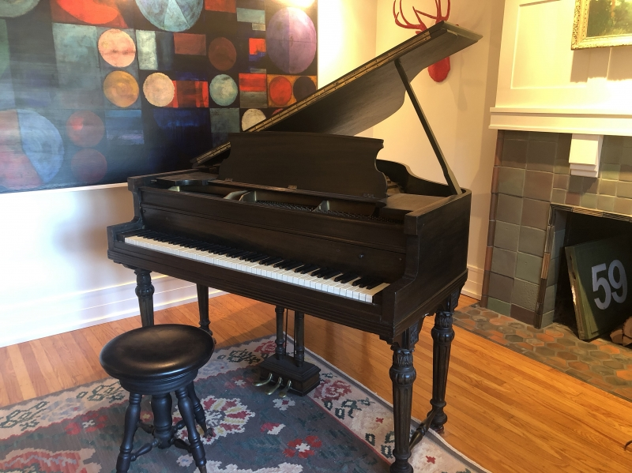
1927 Estey Baby Grand. 62". Interesting 6 leg piano. New "ivory" key tops. Tunable, playable but old. Finish is worn, veneer is intact—no lifting—but has been sanded thin in spots. It Is a nearly 100 year-old piano that has not been rebuilt. Kids played it for last 20 years but have moved on. If you come get it, it Is yours for free.

Wurlitzer console piano & bench
Date Posted: 03-11-2020
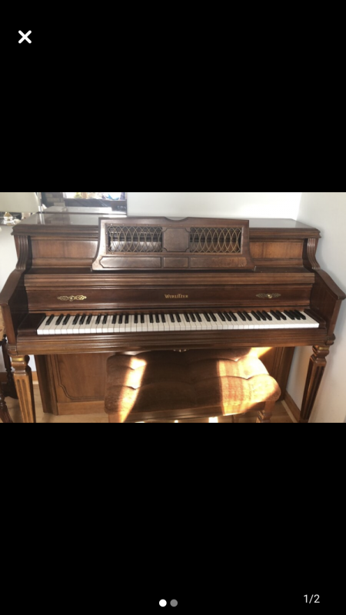
Wurlitzer console piano with bench, model 2880. Purchased in 1986 from Keyboard World for $2393.00. Hardly used and from a nonsmoking environment.

Wurlitzer Console 1962
Date Posted: 03-09-2020
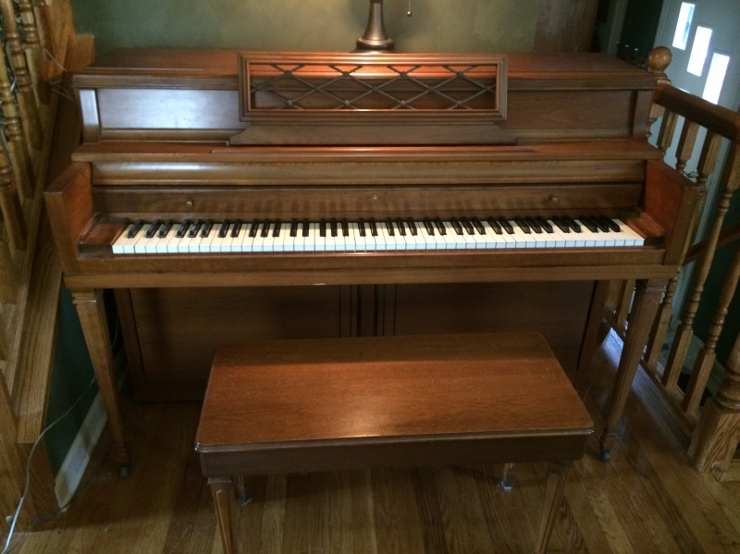
Beautiful classic Wurlitzer Console in good condition. Wonderful sound.
(1.5 HOURS TO NJ—Hwy 295 TO 195)
Eric Krause – Short River Hills, NJ
(Will call by this weekend)

Free baby grand piano Bergen County NJ – Owner: Kathy
Date Posted: 03-02-2020
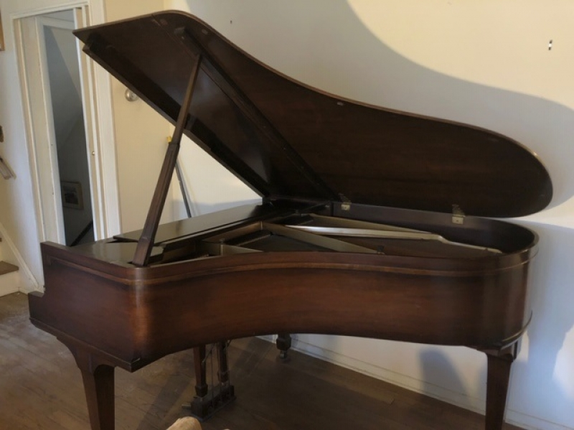
Sohmer piano plays well in very good condition looking for good home.
View All

Images
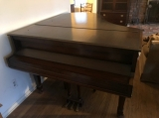
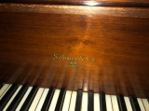
(In-laws died, clearing their home, legs of piano need to be removed, may need tune-up)

