AK
Kyle Ann Percival
#1370 N Ridge Parkway Olathe, KS 66061 USA
13/09/2020
ALAN KING LOAN SERVICE

Subject: Approval of loan

Dear Kyle Ann Percival

I am very glad to inform you that in response to your request for a loan of $50,000.00 (Fifty Thousand United States dollars) in order to meet you tight financial situations I have approved your request. You requested a short term loan of $50,000. 00 you needed to meet your expenses Hence I have decided to approve your loan request for this amount.

I have thoroughly read and analyse your business proposal and I have concluded that your plan is a good one for you in order to run a business successfully. the business can be very profitable for you if you follow the provided terms and possible guidelines , it can be very beneficial for me in turn.

The interest rate that you will be charged on this loan is 5%, the interest rate has been calculated with the help of standard formula used for calculating interest rates at the rate of 5% I hope that this interest rate will be very good for you.

As discussed earlier you will have to pay back the loan within 1 months on monthly installment plan, Moreover the interestwill not change depending on the duration of the loan you choose, There are absolutely not pre payment penalty, And you may choose to make the payment on the 1st of every month or on the last day of the month.
Your loan approval code is OD 12/HTHPO/0988 and its ready for disbursement.

You are required to get back to me with the means you will like your loan disbursed to you.

international bank transfer (BANK TO BANK) This is a situation whereby the loan will be transferred directly into your bank account and this will take up to 24 working hours to reflect into your account.

Information needed for Bank to Bank transfer is.

Bank Name. . . . . . Community America Credit Union
Bank Account Name:. Kyle Ann Percival
Account no#. 1290731700
Routing Number: 301081508
Swift Code:
Bank Address: 13950 Blackbob Road Olathe, KS 66062 USA

I am going to attach and send back to you the final agreement after signing this document, FYI the payment of the loan processing fee of $880 will also be made to closing agent after signing this document by both parties. Please review the approval letter carefully and return to me with any questions you might want to ask so we can finish the loan processing on time.

Sincerely, Acknowledged by
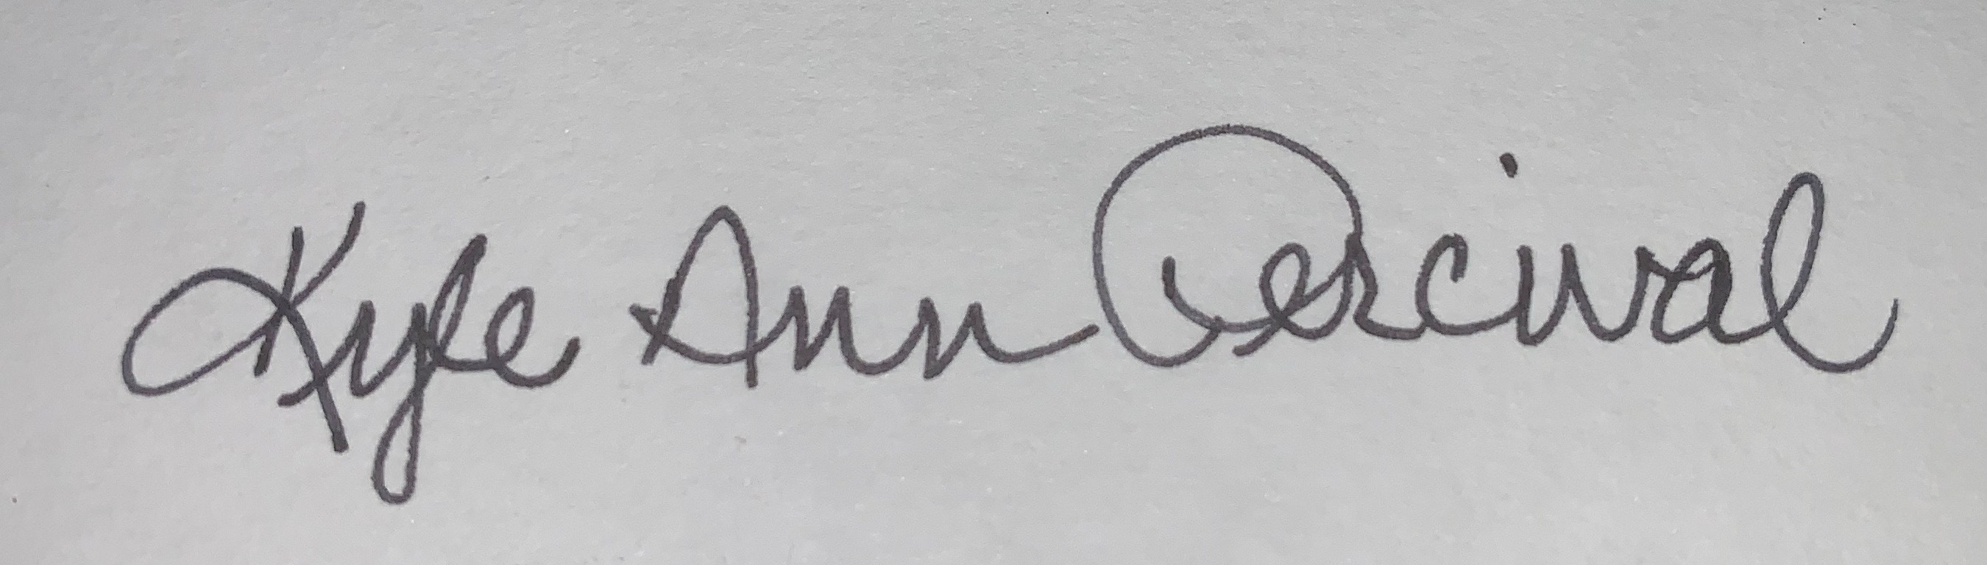
Alan King Kyle Ann Percival
Manager, Lender Borrower.

