Please find below 20 simple steps which will help you to manage with dashboard. Make sure to review the information properly and apply for each and every package. Contact your manager/ supervisors in case if you need any assistance.

!!!IMPORTANT GOLDEN RULES!!!
Rule 1- Log in to dashboard at least 3 times every day, Mon- Fri
Rule 2- Report the packs as soon as they arrive (latest within 3 hours from the delivery time)
Rule 3- Sent out packs on the very same day when outgoing shipping label provided
Follow the rules mentioned above as we have very strict deadlines and no performance delay is accepted. This will be main duties of Quality Inspector, TO PROVIDE TIMELY AND QUALITY WORK PERFORMANCE by reporting and sending packages ONTIME.

Instructions.
EXPECT INCOMING PACKAGE
1) Log in to Your dashboard.
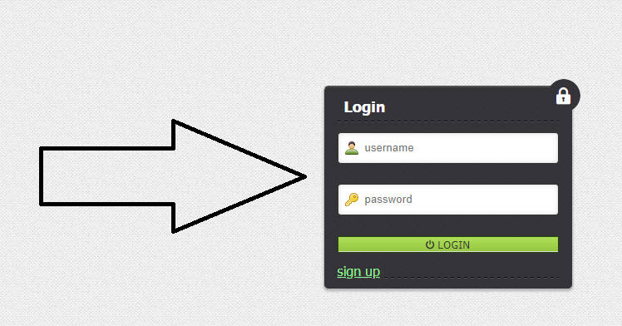

2) You will be on your dashboard MAIN Page. You may refer to HELP section in order to review “General Dashboard Instructions”, “Label Placement Guideline” and “Unboxing Policy”

3) Click on “Packages” located on the left hand side, under menu options.
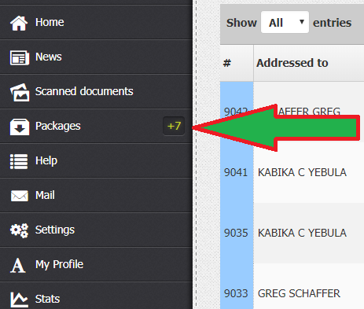

4) You will be able to see all packages on your dashboard.
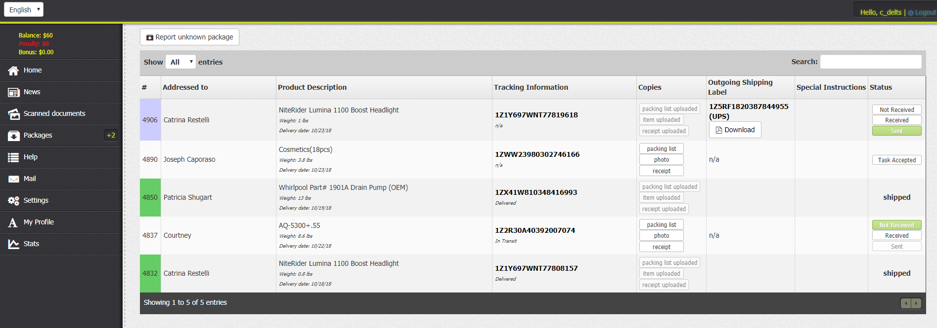

5) All your incoming packages will be in white color ID.

6) As soon as you see new package you need to notify the system that you waiting for the package. Click on small button which says "Task received" on the very right hand side column. It is under column "Status".
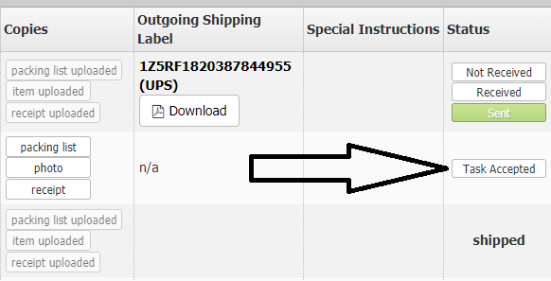

6) Track all incoming packages for estimated delivery date through shipping carrier's website simply by clicking the tracking number of the package.
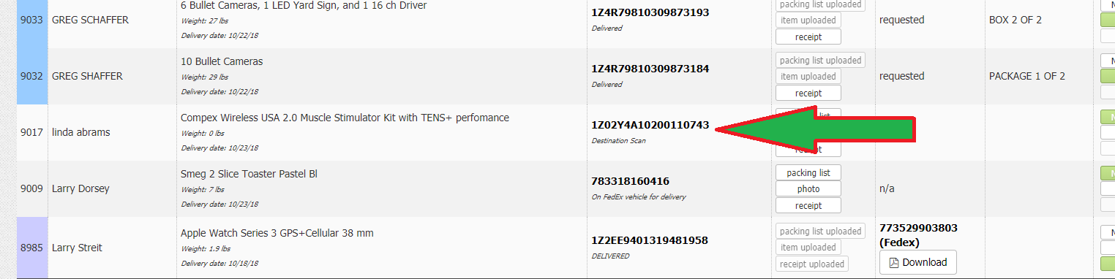

7) When you receive a package, confirm it by clicking "Received" in the table named "Status". on your Dashboard. Note that name on packages may not be yours (may have customer's or shopping manager's name).

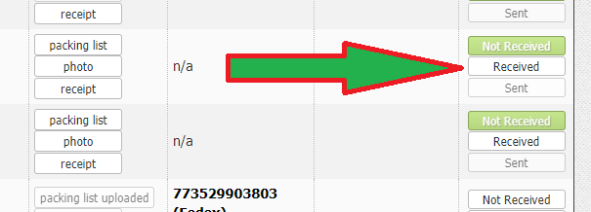
OPEN THE CARRIERS BOX (brown box).
8) Inside the box, you will find “Invoice” or “Packing list”. Upload a copy (scan it or take a photo) of the packing list from inside the box by pressing the button "Packing List" in the table named "Copies".
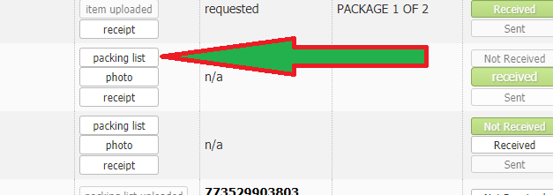
9) Examine the incoming package. Do not remove product's original sealing. Take a picture of product and upload it by pressing the button "Photo" in the table named "Copies".
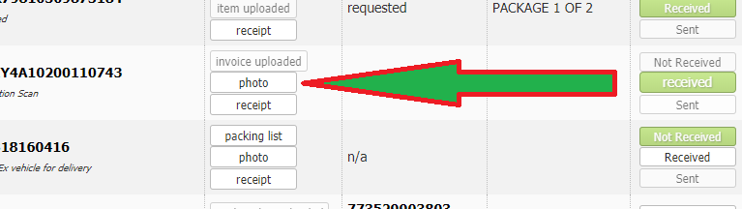
10) Remove all previous shipping labels from inside and outside the box.
12) Remove all warning stickers from the package.
13) Make sure you have removed previous labels and markings (you can remove markings with a heavy black marker), stickers, price tags, invoices and any other papers. Most of the packages are shipped out in the same packaging box in which it has arrived.
14) Place cushioning all around the items. You can use newspaper, or shredded paper. Close and shake the box to see if you have enough cushioning. If you hear items shifting, add more cushioning.
15) Tape the opening of your box and reinforce all seams with tape. Use clear or brown packaging tape, reinforced packing tape or paper tape.
SEND OUT PACKAGE.
16) As soon as we receive the payment from the customer, the outgoing shipping label is uploaded under "Outgoing Shipping Label" table. (Note that we can keep customer's packages up to 30 days for free). Once the download button is active, click it to download the shipping label.
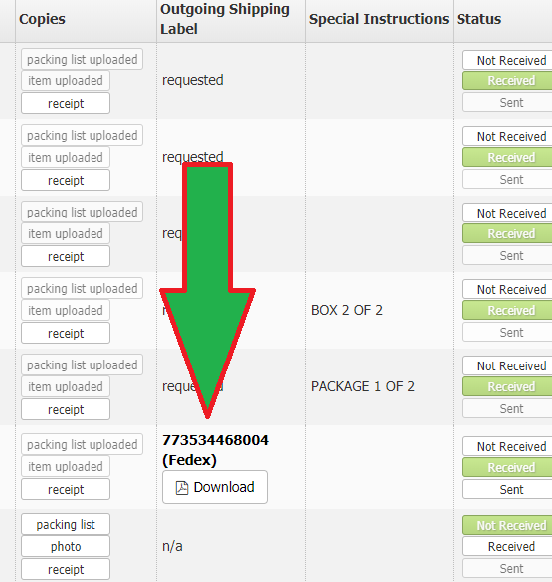
17) Print out a copy of the shipping label and stick it properly to the box. (Check Label Placement from HELP section in your dashboard menu)
18) Drop the packages at the nearest USPS, UPS or FedEx office, depending on type of shipping label you've been provided. You don't have to pay anything when shipping packages out!
19) When a package is shipped out, confirm it by clicking "Sent" in the table named "Status".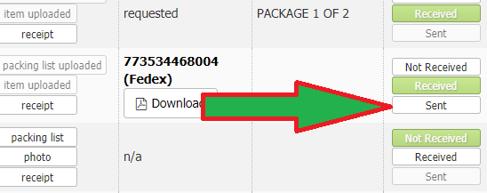
20) Upload a copy of the Drop-off Package Receipt by clicking "Drop-off Receipt" in the table named "Upload Copies" if you were provided with one at the shipping carrier's location (if you used drop of location and don’t have receipt, you don’t have to provide any picture).
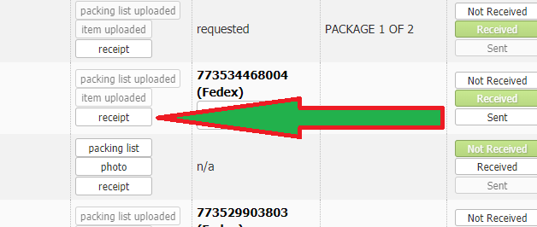
Important! If a package is delivered but you can't find it on your Dashboard, you need to report it by clicking "Report Unknown Package" button. Please provide the following: tracking number, name on the package (recipient's name), weight and brief description of the items.
