Skip to content

Thank you for your purchase!
Show order summaryHide order summary$59.90

Thank you for your purchase!
Order #4826

Thank you Darlene!

Your order is confirmed
We’ve accepted your order, and we’re getting it ready. Come back to this page for updates on your shipment status.

Order updates
Track order with Shop app

Mobile phone number
Submit
You'll receive a text with a link to the Shop app to help track your order.

Customer information

Contact information
nasonfamily@yahoo.com

Shipping address
Darlene Nason
14474 Town Hall Hwy
Millersburg MI 49759
United States

Shipping method
Standard

Payment method
- Visaending with 3947 - $59.90

Billing address
Darlene Nason
14474 Town Hall Hwy
Millersburg MI 49759
United States
Continue shopping
Need help? Contact us
Opens external website in a new window. Opens in a new window. Opens external website. Customer information - Bug Me Out / Sunnyside Yoga - Checkout
- Refund policy
- Shipping policy
- Privacy policy
- Terms of service

Thank you for your purchase!

Order summary
Shopping cart
Product image | Description | Quantity | Price
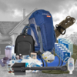  2 | The Ultimate 72 Hour Bugout Bag | 2 | $59.90
Scroll for more items
Cost summary
Description | Price
Subtotal | $59.90
Shipping | Free
Total Including $0.00 in taxes | USD $59.90
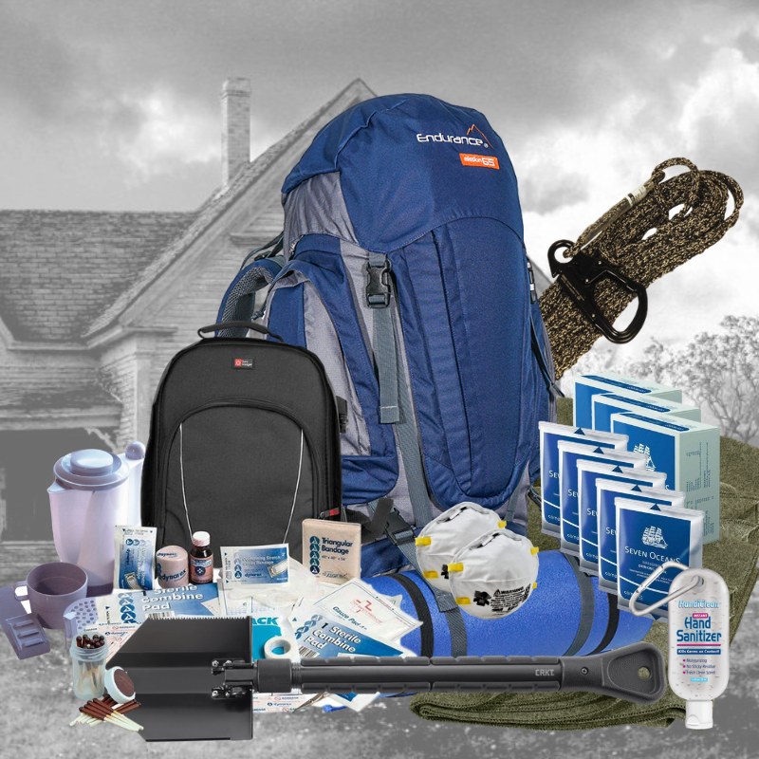

Anne in Austin purchased

The Ultimate 72 Hour Bugout Bag
3 months ago

