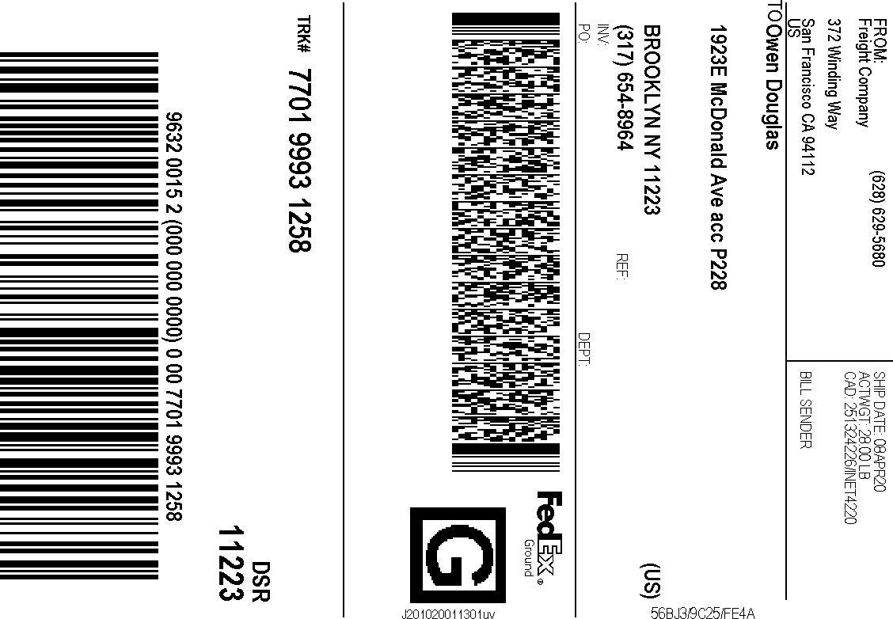

After printing this label:
- Use the 'Print' button on this page to print your label to your laser or inkjet printer.
- Fold the printed page along the horizontal line.
- Place label in shipping pouch and affix it to your shipment so that the barcode portion of the label can be read and scanned.

Warning: Use only the printed original label for shipping. Using a photocopy of this label for shipping purposes is fraudulent and could result in additional billing charges, along with the cancellation of your FedEx account number.
Use of this system constitutes your agreement to the service conditions in the current FedEx Service Guide, available on fedex.com.FedEx will not be responsible for any claim in excess of $100 per package, whether the result of loss, damage, delay, non-delivery,misdelivery,or misinformation, unless you declare a higher value, pay an additional charge, document your actual loss and file a timely claim.Limitations found in the current FedEx Service Guide apply. Your right to recover from FedEx for any loss, including intrinsic value of the package, loss of sales, income interest, profit, attorney's fees, costs, and other forms of damage whether direct, incidental,consequential, or special is limited to the greater of
$100 or the authorized declared value. Recovery cannot exceed actual documented loss.Maximum for items of extraordinary value is $1,000, e.g. jewelry, precious metals, negotiable instruments and other items listed in our ServiceGuide. Written claims must be filed within strict time limits, see current FedEx Service Guide.

